July 29, 2025

**Global Alerts – West Zone**

**HURRICANE IONA**

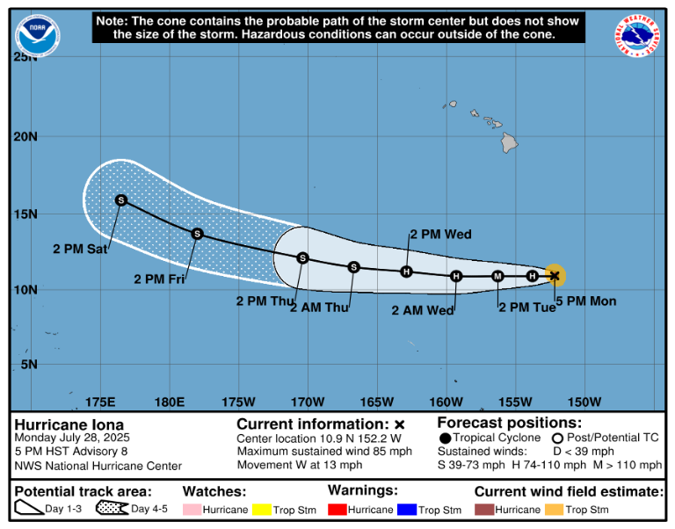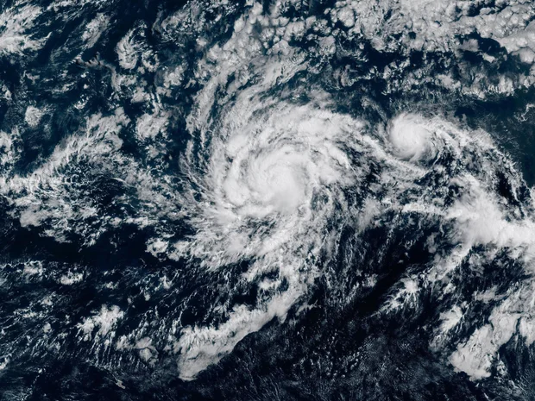

**Duration**

July 27 – 1ST August, 2025.

**Hazard Summary**

Two tropical cyclones were swirling across the ocean southeast of Hawaii after developing on Monday but were not expected to cause any issues for the islands [Hurricane Iona](https://economictimes.indiatimes.com/topic/hurricane-iona) is the first named storm of the [hurricane season](https://economictimes.indiatimes.com/topic/hurricane-season) in the central Pacific and emerged Sunday from a tropical depression to become a Category 1 hurricane in roughly a day. It was trekking west over warm, open waters. Iona was located several hundred miles south-southeast of Hawaii's capital city of Honolulu on Monday. The center of Hurricane Iona was located near latitude 10.9 North, longitude 152.2 West. Iona is moving toward the west near 13 mph (20 km/h). This motion is expected to continue with a gradual increase in forward speed during the next

couple of days. Maximum sustained winds are near 85 mph (140 km/h) with higher

gusts. Iona expected to become a major hurricane on Tuesday. Steady weakening is expected to begin by Wednesday. Hurricane-force winds extend outward up to 15 miles (30 km) from the center and tropical-storm-force winds extend outward up to 60 miles (95 km). The estimated minimum central pressure is 985 mb (29.09 inches). There are no coastal watches or warnings in effect.