**Tropical Storm Dexter**

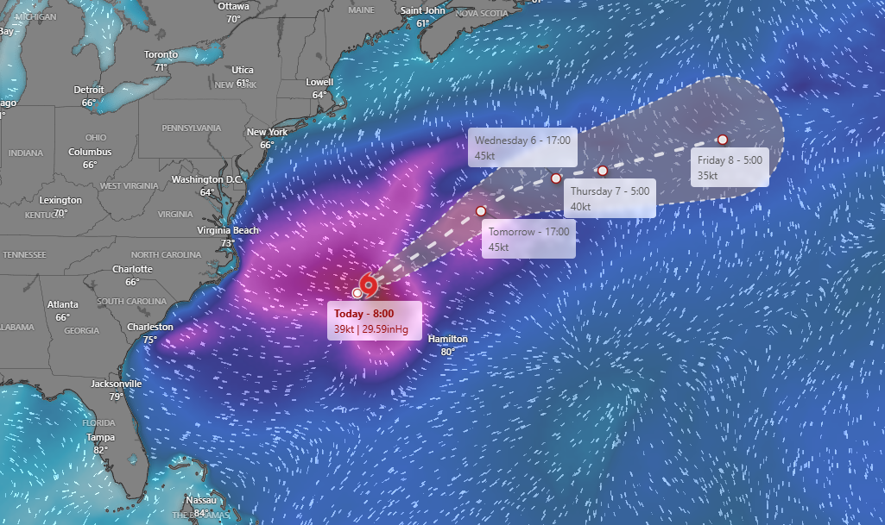

As of late Sunday night, the storm’s center is on the edge of the thunderstorm activity because of winds blowing from the southwest. Recent satellite data shows winds near the center are strong enough, around 45 mph, for it to be classified as a tropical storm. Dexter is moving toward the east-northeast at about 10 mph. It's being steered by winds high up in the atmosphere and is expected to keep moving in that direction for the next few days. While most forecasts agree on where it's going, there’s some uncertainty about how fast it will move. Some models suggest it could slow down and wander a bit, but the current forecast sticks with a faster pace. The storm is expected to face stronger upper-level winds soon, which will likely prevent it from getting any stronger. Most forecasts suggest it will stay about the same strength for the next couple of days, with winds staying between 45 to 55 mph. Because of those strong winds higher up, Dexter will probably lose its tropical characteristics in about two and a half days, maybe sooner. After that, it may turn into a different kind of storm and eventually get absorbed into another weather system by the end of the week, though that part of the forecast is still uncertain.