**Heavy Rain/Flood – North Carolina**

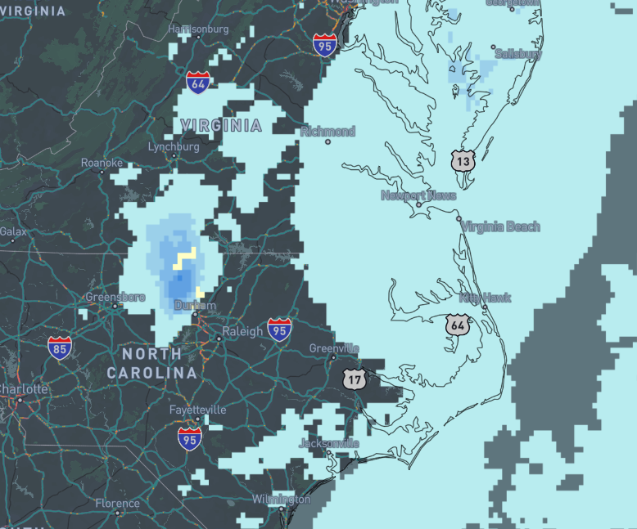**Affected Areas**

Deep River at Moncure affecting Chatham and Lee Counties. Cape Fear River at Lillington affecting Harnett County.

**Duration**

July 7-9, 2025

**Hazard Types**

Heavy Rain/ Floods

**Hazard Summary**

Deep River at Moncure affecting Chatham and Lee Counties moderate flooding is forecasted. The river is expected to rise to a crest of 15.1 feet early this morning. It will then fall below flood stage early Wednesday morning