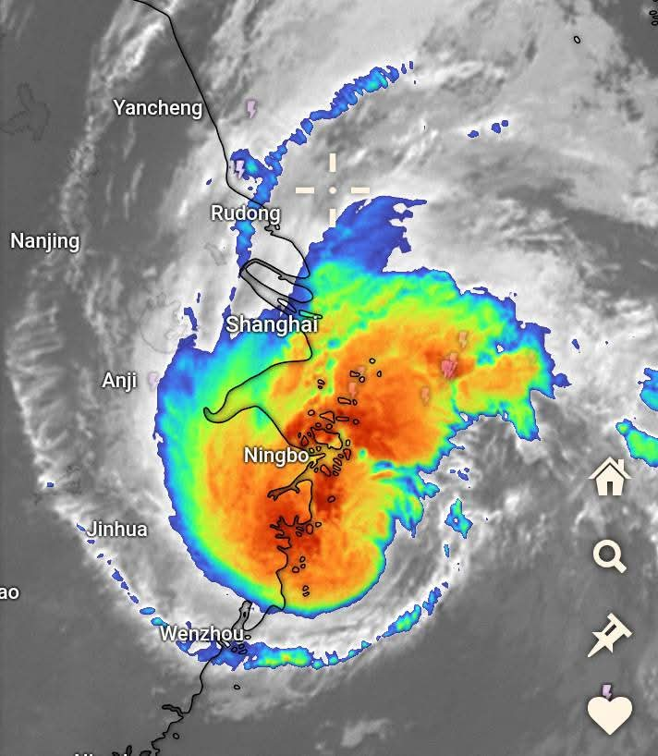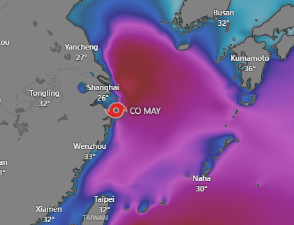

Over the past 15 days, this is the third and most powerful storm Co-May heading toward China. It is expected to make landfall, pass through the major city of Shanghai, and then move northward toward Beijing, where severe rainfall is already ongoing. Southern and eastern provinces of China have been experiencing relentless rainfall, with daily accumulations reaching 300 to 400 mm. shanghai relocated more than 280,000 people, halted hundreds of flights and ferry services and imposed speed limits on roads and railways on Wednesday (Jul 30) as a [tropical storm](https://www.channelnewsasia.com/east-asia/rain-stroms-dump-year-rain-northern-china-19000-evacuated-5258491) whipped eastern China with gales and heavy rain. Co-May's landfall in the port city of Zhoushan in Zhejiang province in the early hours of Wednesday was soon followed by warnings of a tsunami set off by a [powerful earthquake off Russia's far east](https://www.channelnewsasia.com/east-asia/japan-tsunami-warning-earthquake-hokkaido-russia-hawaii-5266181), raising concerns of larger-than-expected storm surges along the Chinese coast.