**Heat Wave – Coachella Valley and San Diego County**

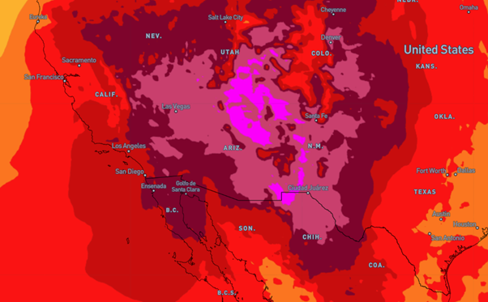

**Affected Areas**

Coachella Valley and San Diego County

**Duration**

July 6 -July 10, 2025

**Hazard Types**

Dangerously hot conditions with increased relative humidities

**Hazard Summary**

Dangerously hot conditions with increased relative humidities in Coachella Valley and San Diego County. Heat related illnesses increase significantly during extreme heat events. Risk for heat-related illnesses for most individuals sensitive to heat, especially those without effective cooling and/or adequate hydration.