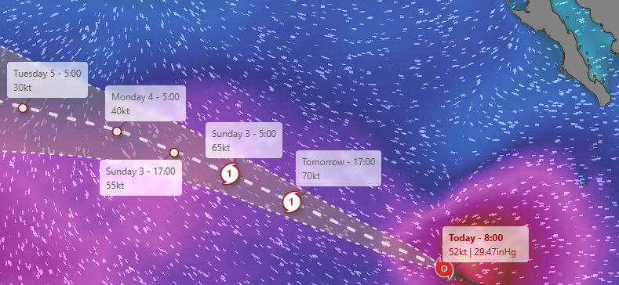

Tropical Storm Gil was strengthening in the eastern Pacific Ocean on Thursday but wasn't expected to threaten land. The storm is forecast to remain over open water and become a [hurricane](https://apnews.com/hub/hurricanes) on Friday. It's about 805 miles (1,295 kilometers) southwest of the Baja California peninsula of Mexico. Gil had maximum sustained winds of 50 mph (85 kph) and was moving west-northwest at 13 mph (20 kph) There are no coastal watches or warnings in effect. The storm is expected to keep traveling to the west-northwest in the coming days, as well as speed up as it crosses over the ocean.