**Heat Wave in the Central and Southeast U.S**

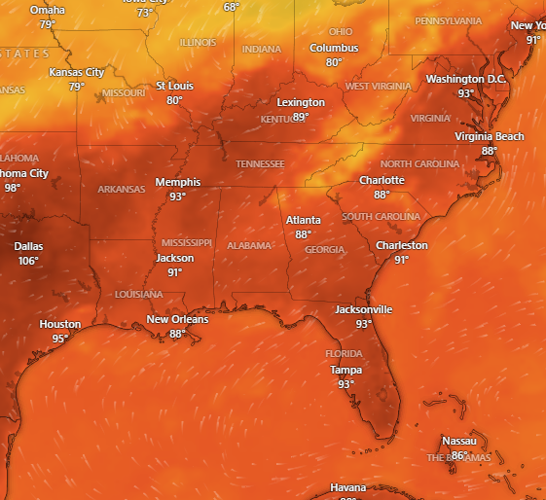

**Duration**

July 29-1ST August, 2025

**Hazard Summary**

Extreme heat is expected to intensify across much of the Southeast and Tennessee Valley, continuing through much of this week. Heat index values up to 103 expected. Hot temperatures and high humidity may cause heat illnesses. Drink plenty of fluids, stay in an air-conditioned room, stay out of the sun