**Flooding – Texas**

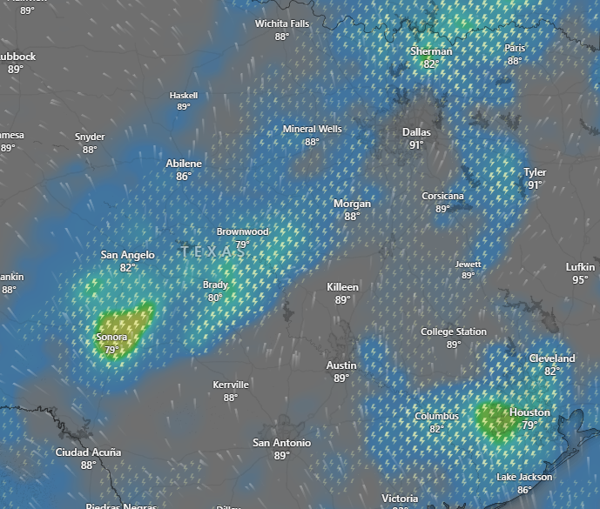

**Affected Areas**

Texas

**Duration**

July 7-8, 2025

**Hazard Types**

Heavy Rain/ Thunderstorm/ Floods

**Hazard Summary**

The River Flood Warning for the San Saba River at San Saba continues until tomorrow evening. The river continues to fall from it’s early-morning. The forecast continues a 50% chance of rain and thunderstorms. A few heavy downpours will be possible today which could lead to flash flooding.