July 14, 2025

**Heat Wave–Western Nevada and Northeast California**

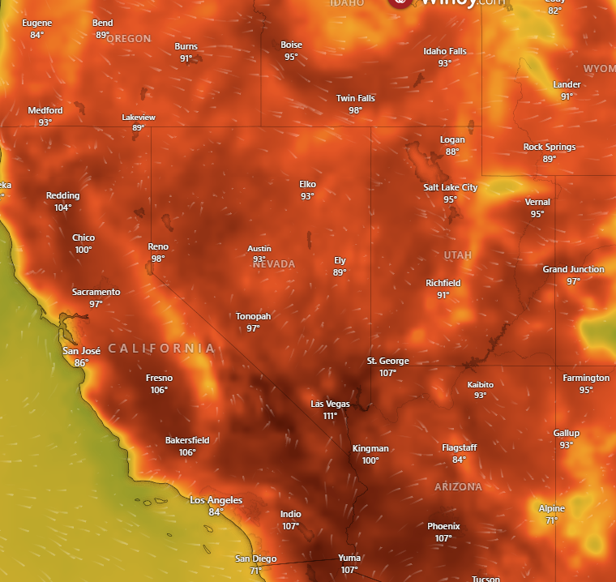

**Affected Areas**

Western Nevada and Northeast California

**Duration**

July 12-16, 2025

**Hazard Types**

Heat Wave

**Hazard Summary**

Heat Advisory in effect for Western Nevada and Northeast California from Saturday until Wednesday. Major Risk of heat related illness for much of the population without protective actions.