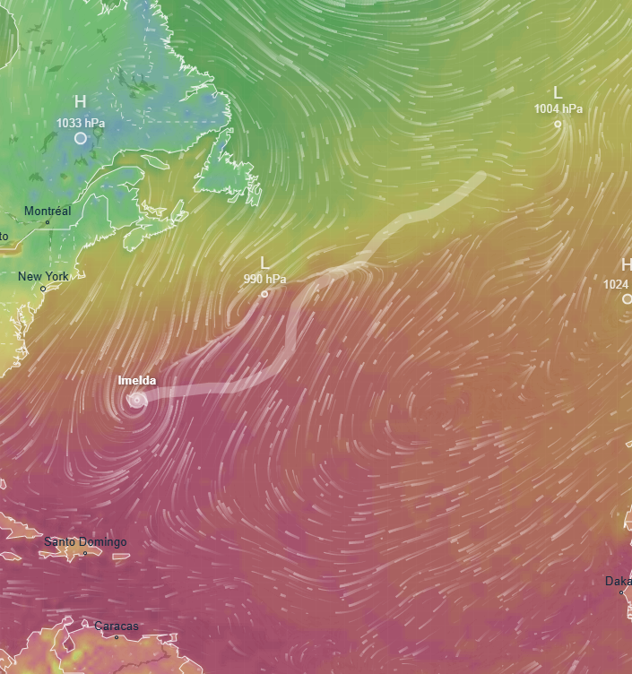

At 1100 PM (0300 UTC), the centre of Hurricane Imelda was located near latitude 32.1 North, longitude 65.0 West. Imelda is moving rapidly toward the east-northeast near 29 mph (46 km/h) and this general motion is expected to continue through Thursday night. A north eastward motion is then forecast on Friday and Saturday. On the forecast track, the core of Imelda will move across Bermuda over the next few hours overnight, before moving away from the island during the day. Maximum sustained winds remain near 100 mph (155 km/h) with higher gusts. Imelda is expected to become an extratropical low on Thursday, with gradual weakening forecast thereafter.

* WIND: Hurricane conditions are ongoing over Bermuda and expected to continue through early Thursday. Significant hurricane-force wind gusts are likely across Bermuda even after the centre passes.
* RAINFALL: Across Bermuda, 2 to 4 inches (50 to 100 mm) of rainfall is expected from tonight into Thursday, which could lead to flash flooding.
* STORM SURGE: In Bermuda, a dangerous storm surge is expected to produce coastal flooding in areas of onshore winds. The surge will be accompanied by large and damaging waves.
* SURF: Swells generated by Imelda are affecting the Bahamas, Bermuda, and much of the U.S. East Coast. Swells from Imelda will spread toward the Greater Antilles and northern Leeward Islands on Friday and continue through the weekend. These swells are likely to cause life-threatening surf and rip current conditions.

.