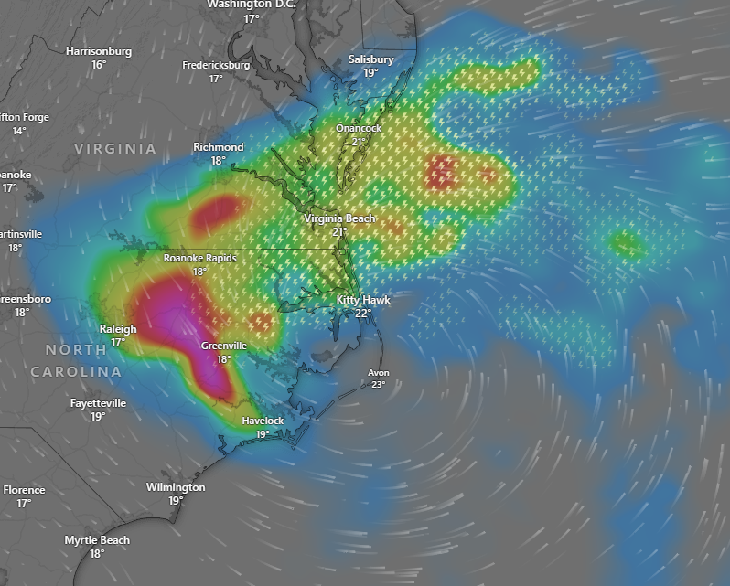

A developing low-pressure system near a stationary front is expected to strengthen and move toward the Outer Banks of North Carolina on Monday night. This weather pattern, similar to a cold-season, is likely to bring heavy rainfall and windy conditions, particularly along the coast, starting Monday. By Tuesday morning, the main part of this coastal storm is predicted to make landfall close to the Virginia/North Carolina border, where there is a possibility of several inches of wind-driven rain extending further inland into northeast North Carolina and southeast Virginia. Meanwhile, a Pacific cold front making landfall along the coast of the Pacific Northwest will bring a period of cooler-than-normal temperatures to the region through Monday. In addition to the drop in temperatures, this front will also initiate scattered showers and thunderstorms across the Pacific Northwest this evening, followed by similar weather in the Northern Rockies later today and into Monday. Dry weather is anticipated to return to the Pacific Northwest by Tuesday.