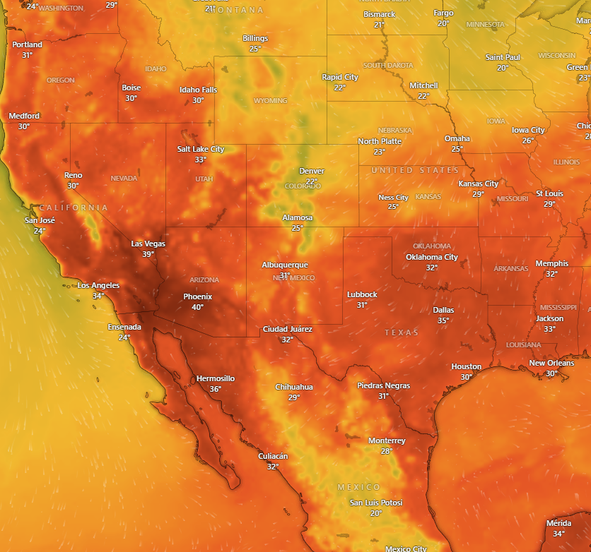

A dangerous, record heat wave will continue across the Desert Southwest and the Central Valley of California through saturday. A strong upper-level high continues to bring the chances for dangerous heat over much of the western U.S. the next couple of days and will continue into the weekend. Parts of the western U.S. will be under a Major Heat Risk through the weekend, with isolated areas experiencing Extreme Heat Risk conditions. Widespread heat-related warnings and advisories are in effect across much of inland California/Oregon and Nevada as highs climb into the 90s and 100s, and across the Desert Southwest as highs climb into the 110s. This dangerous level of heat will pose a threat to anyone without effective cooling and adequate hydration. Highs into the 90s more broadly across the West will still pose a threat to anyone more sensitive to heat or engaging in strenuous outdoor activities. By the end of the weekend, temperatures over central to southern western U.S. begin to cool but Northern Pacific will continue to experience above normal temperatures into the work-week.