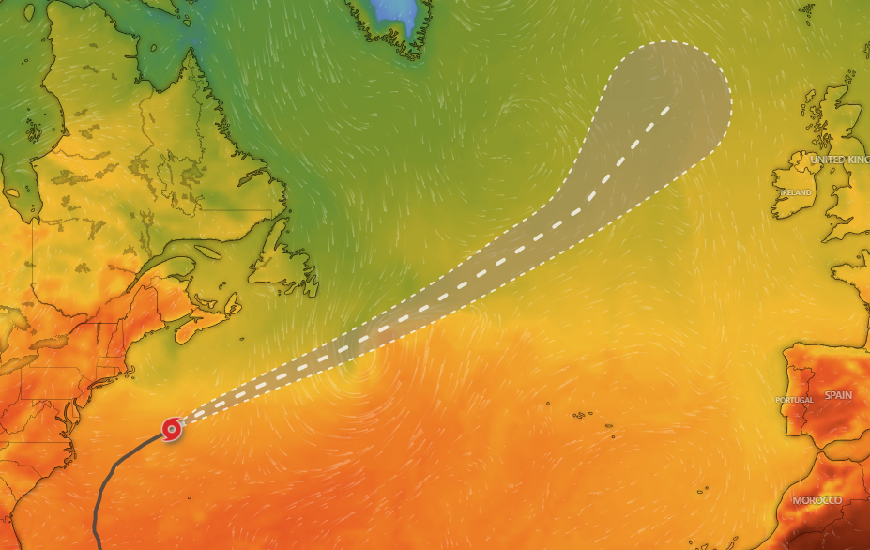The center of Hurricane Erin is located near latitude 37.3 North, longitude 67.0 West. Erin is moving toward the east-northeast near 22 mph (35 km/h). A faster north eastward to east-north eastward motion is expected during the next couple of

days. On the forecast track, the center of Erin will move over the western Atlantic between New England and Bermuda through early Friday, and then pass south of Atlantic Canada Friday and Saturday. Maximum sustained winds are near 100 mph (155 km/h) with higher gusts. Gradual weakening is forecast during the next couple of days, and Erin is expected to become post-tropical on Saturday. Erin remains a very large system. Hurricane-force winds extend outward up to 105 miles (165 km) from the center and tropical-storm force winds extend outward up to 320 miles (520 km). During the past few hours, wind gusts to tropical-storm force have been reported on Bermuda and on Nantucket Island, Massachusetts. The estimated minimum central pressure is 952 mb (28.12 inches). Several areas along the coast are under a tropical storm watch, storm surge warning, and coastal flood warning as Hurricane Erin continues to trek north eastward along the East Coast. Erin will continue to bring

strong gusty to tropical storm force winds along the North Carolina Outer Banks and northward along the Mid-Atlantic Coast through the coast of southern New England tonight through Friday. In addition, storm surges can bring large waves, leading to significant beach erosion and overwash, and some roads may become. Hazardous beach conditions, life-threatening surf, and rip currents will remain a serious concern more broadly along the East Coast and will likely last through at least the next couple of days. Beachgoers should follow advice from lifeguards, local authorities, and beach warning flags.