**Tropical Storm Keli**

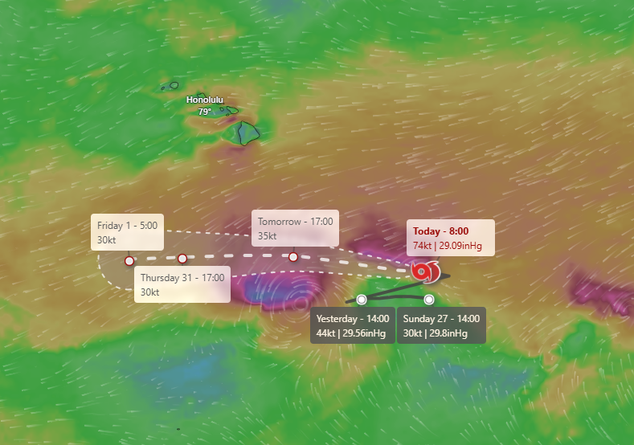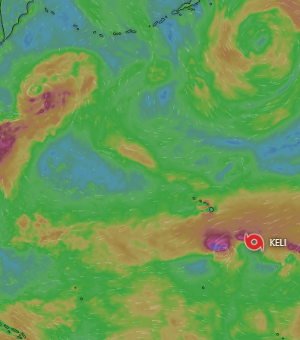

**Duration**

July 27-1ST August, 2025

**Hazard Summary**

[A second weather system also formed.](https://www.nhc.noaa.gov/text/refresh/HFOTCPCP2+shtml/282033.shtml) Keli was located about 1,090 miles southeast of Honolulu. It is moving west at 10 miles per hour and is expected to continue in that general direction for the next several days. Keli’s maximum sustained winds are currently near 40 miles per hour, with stronger gusts. Some slight strengthening is possible over the next day or so, but the storm is forecast to start weakening by midweek. Winds of tropical storm strength extend outward up to 35 miles from the center. The storm’s minimum central pressure is 1008 millibars. At this time, Keli is not a threat to any land areas, and no coastal watches or warnings are in effect